Bonnington Symbol System
City of Edinburgh Council

Symbol resource 2008

including relevant British Standard symbols from BS 8501

Activities
Catering
College
Environments
Health
Home
People
Self development



art
leisure
shopping
sport




The Resource
This resource has been created as a series of word documents which may be printed out to use as a visual reference and index.

Copy and Paste/Instructions
To reproduce an image:
- Single click on the image ensuring it is selected
- Select Copy from the Edit menu (or use keyboard shortcut Ctrl+C)
- Open the document you wish to place the image in (e.g. word document)
- Select Paste from the Edit menu (or use keyboard shortcut Ctrl+V)

Images may be resized by dragging in or out from a corner, images may be resized up to A4 without any loss of quality.

Images may be placed in tables or text boxes.

If you have any difficulty using any of the images please contact BSS using the contact details below.

Acknowledgement British Standards: Permission to reproduce extracts from the BS 8501:2002 is granted by BSI. The British Standards can be obtained from BSI Customer Services, 389 Chiswick High Road, London W4 4AL. Tel +44 (0)20 8996 9001

Acknowledgement BSS Edinburgh Council: Permission to reproduce BSS symbols is granted by The City of Edinburgh Council Health and Social Care; however reproduction of any part of the CD ROM in any form is not permitted.

Disclaimer: The City of Edinburgh Council cannot accept any responsibility for damage caused to your computer or data whilst using this CD.

Contact information: Gordon Fraser, Performance Review Manager. The City Of Edinburgh, Health and Social Care, Waverley Court, 4 Market Street Tel: +44 (0)131 553 8266
www.edinburgh.gov.uk/internet/social_care/CEC_learning_disability

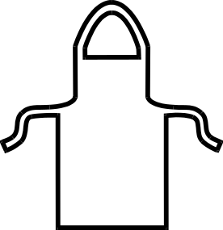 |  | 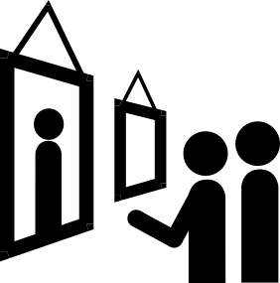
Apron  1750 | Art and design  1751 | Art gallery  BS 8501 8003
 |  | 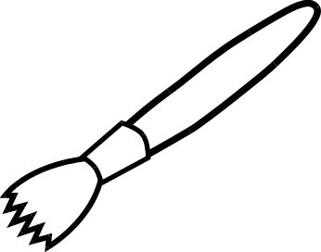
Art shop  1752 | Batik  1753 | Brush-hog hair  1754
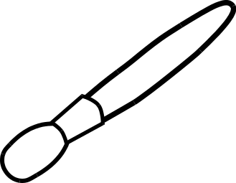 | 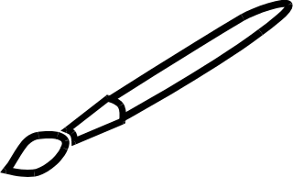 | 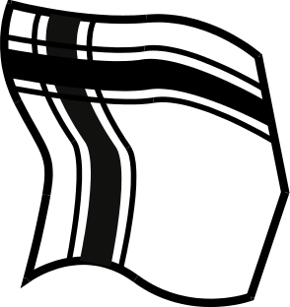
Brush-large  1755 | Brush-small  1756 | Cloth  1757
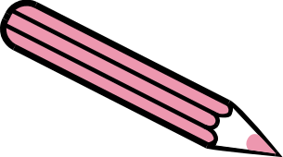 | 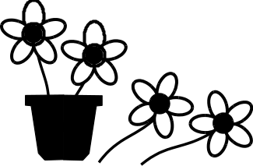 | 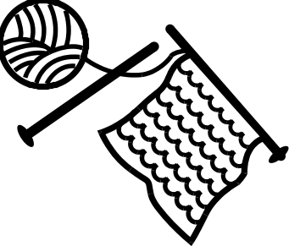
Coloured pencil  1758 | Craft-floristry  1759 | Craft-knitting  1760
Bonnington Symbol System
www.edinburgh.gov.uk
 | 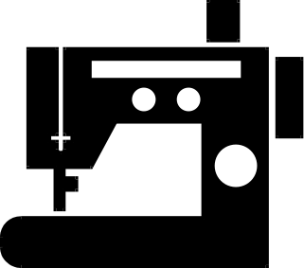 | 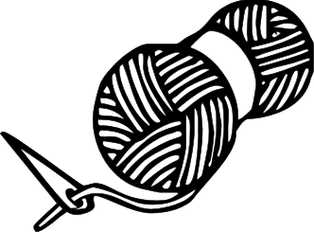
Craft-printmaking  1761 | Craft-sewing using machine  1762 | Craft-wool  1763
 |  | 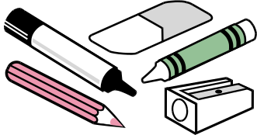
Digital photography 1764 | Discuss artwork  1765 | Drawing materials  1766
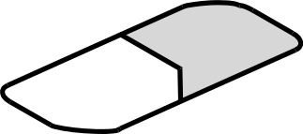 | 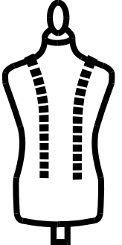 | 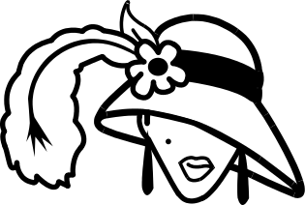
Eraser/rubber  1767 | Fashion #1  1768 | Fashion #2  1769
 |  | 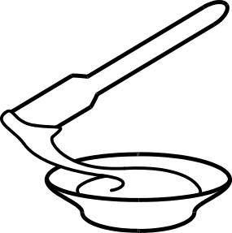
Film making  1770 | Glue  1771 | Glue and glue spreader  1772
Bonnington Symbol System
www.edinburgh.gov.uk

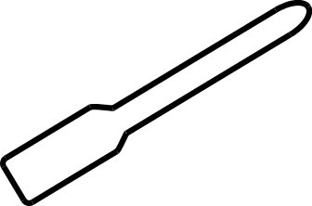 | 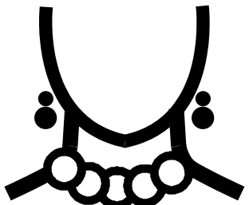 | 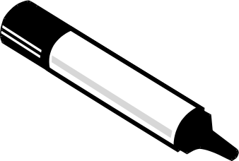
Glue spreader  1773 | Jewellery making  1774 | Marker pen  1775
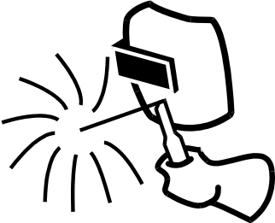 |  | 
Metal sculpture  1776 | Mop and bucket  1777 | Newspaper  1778
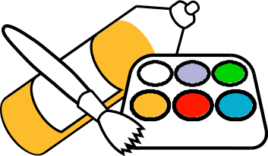 |  | 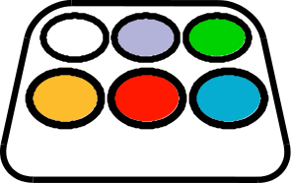
Paint and brushes  1779 | Paint container  1780 | Paint tray  1781
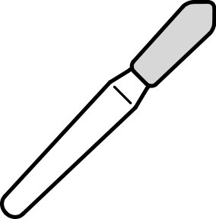 |  | 
Palette knife  1782 | Paper  1783 | Papercraft materials  1784
Bonnington Symbol System
www.edinburgh.gov.uk

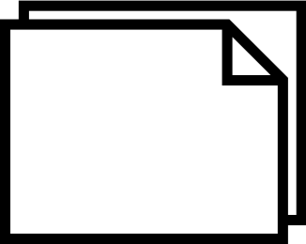 | 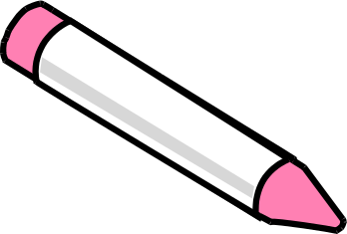 | 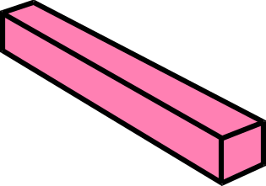
Paper-landscape  1785 | Pastel #1  1786 | Pastel #2  1787
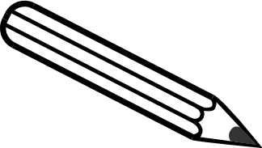 | 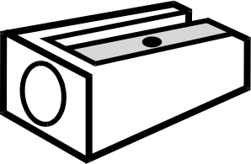 | 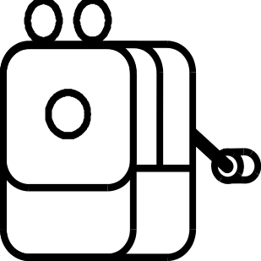
Pencil  1788 | Pencil sharpener #1  1789 | Pencil sharpener #2  1790
 | 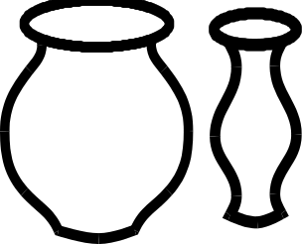 | 
Photography  1791 | Pottery  1792 | Print  1793
 |  | 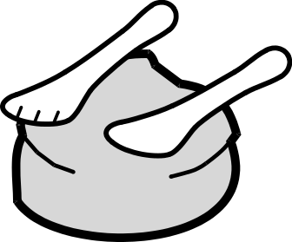
Scissors  1794  Bonnington Symbol System  www.edinburgh.gov.uk | Sculpture  1795 | Sculpture materials  1796
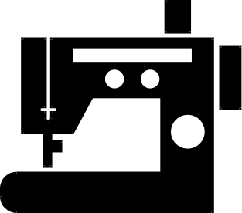 | 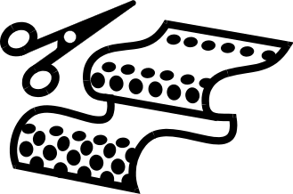 | 
Sewing machine  1797 | Textile and fashion design  1798 | Therapy-art therapy  1799
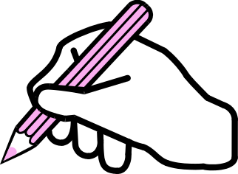 | 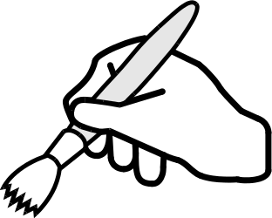 | 
Use drawing materials  1800 | Use painting materials  1801 | Use sculpture/clay materials  1802
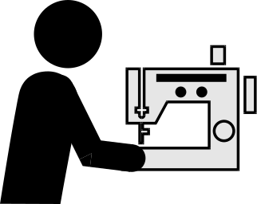 |  | 
Use sewing machine  1803 | Wash up  1804 | Water container  1805
 | 
Wax crayon  1806 | Wipe with cloth  1807
Bonnington Symbol System
www.edinburgh.gov.uk

